Main Menu: Welcome Page

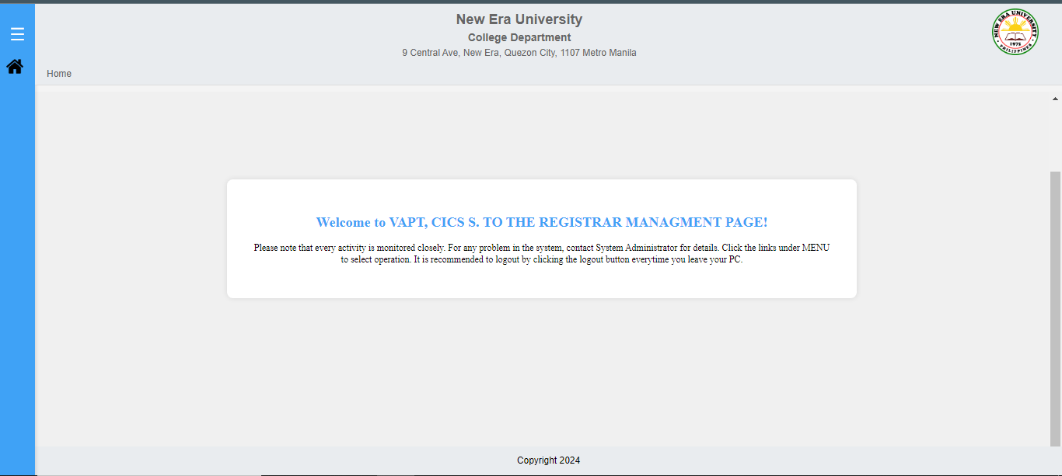  
  
Main Menu: Nav Bar  
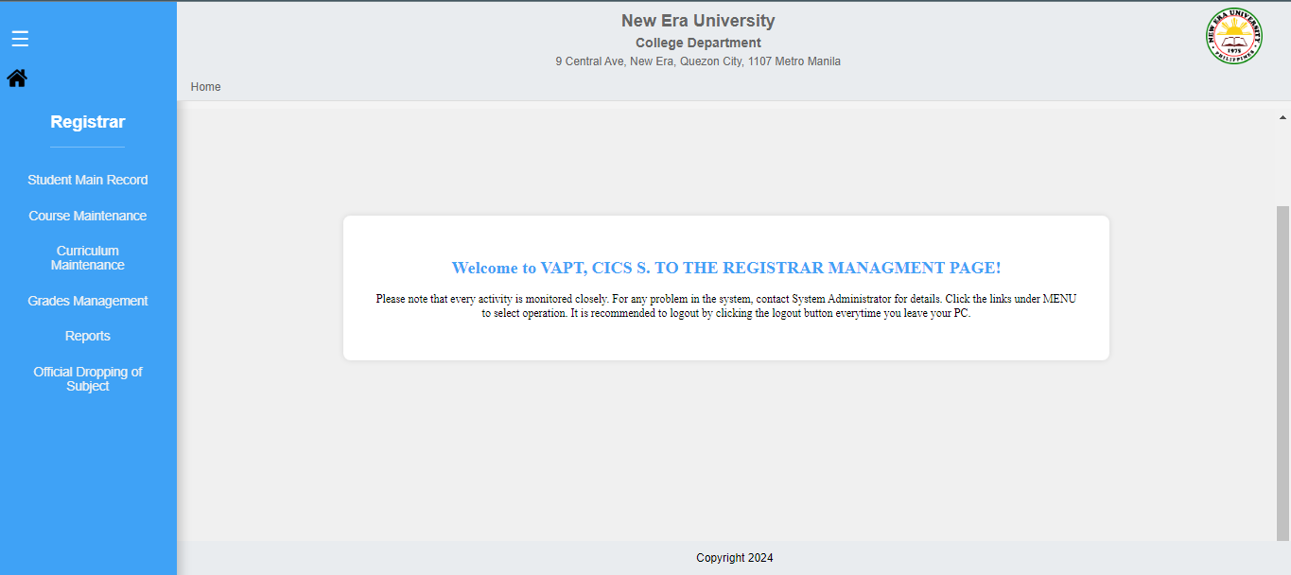  
  
Main Menu: Nav Bar Level 2  
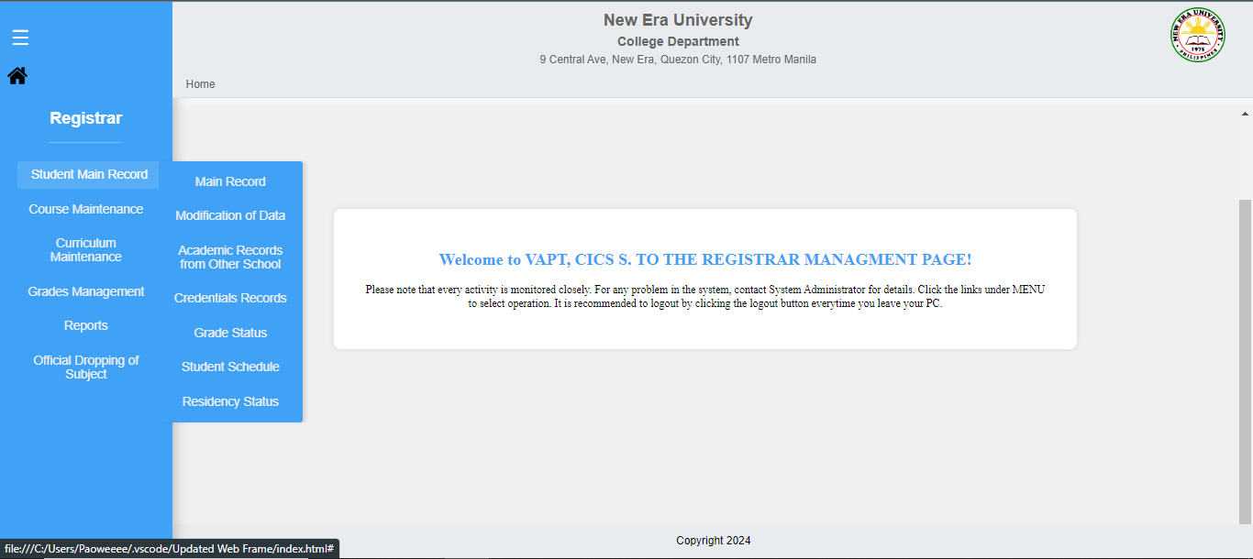

Module: Student Main Record  
Sub-Module: Main Record  
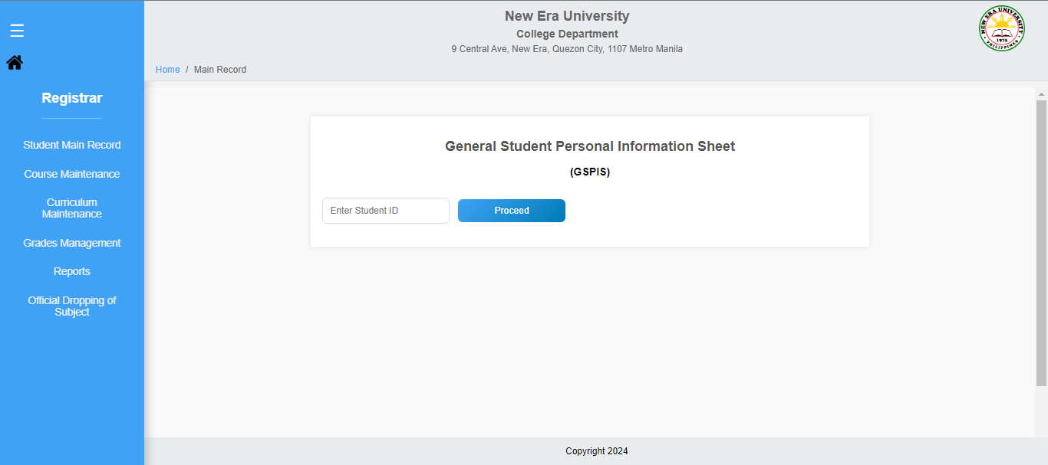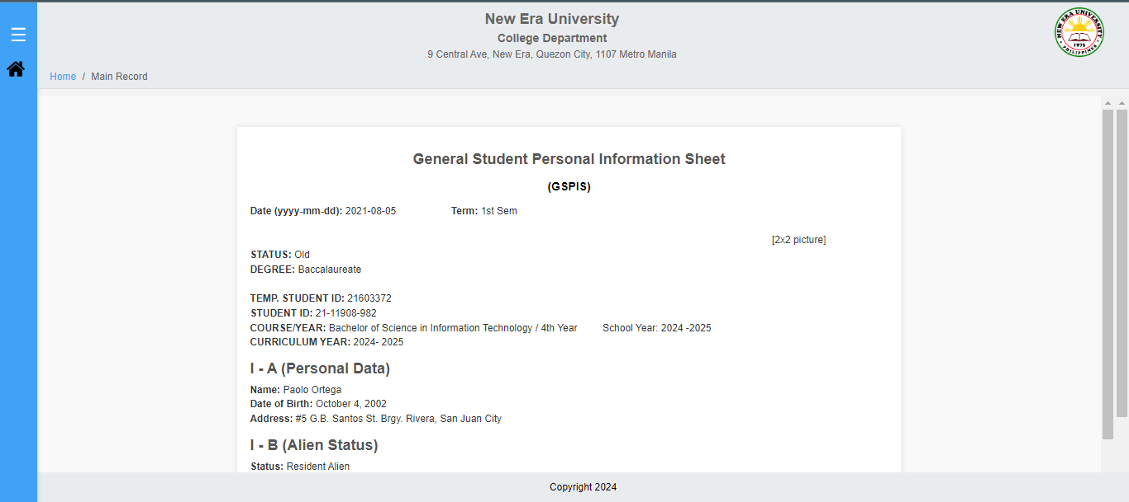

Module: Student Main Record  
Sub-Module: Modification of Data

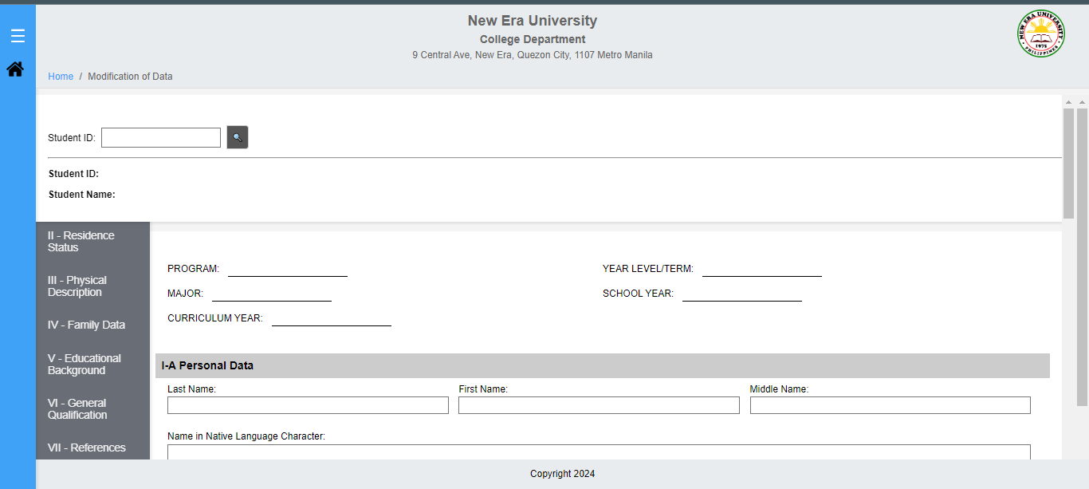

Module: Student Main Record  
Sub-Module: Academic Records from other School

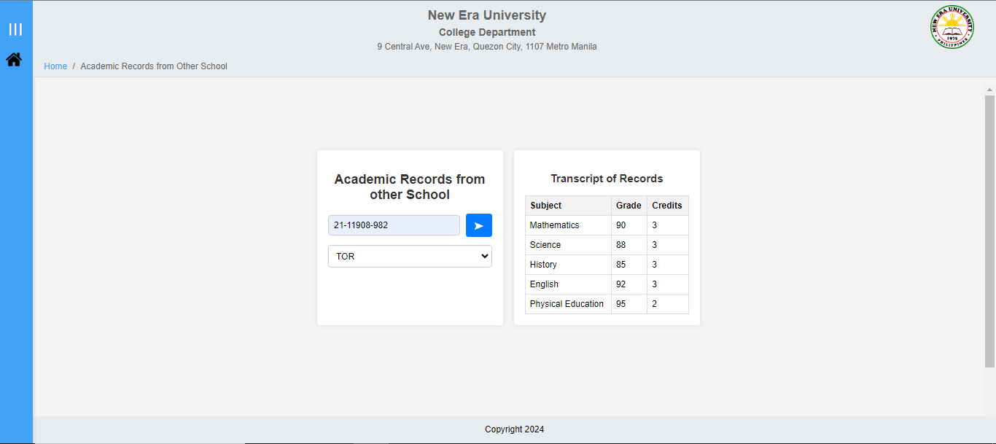

Module: Student Main Record  
Sub-Module: Credential Records  
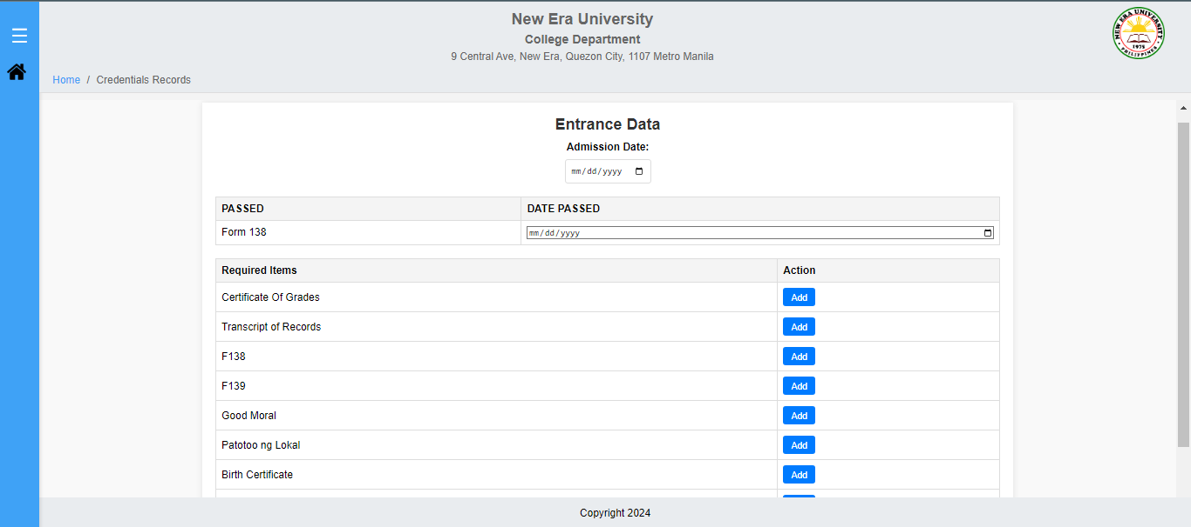

Module: Student Main Record  
Sub-Module: Grade Status

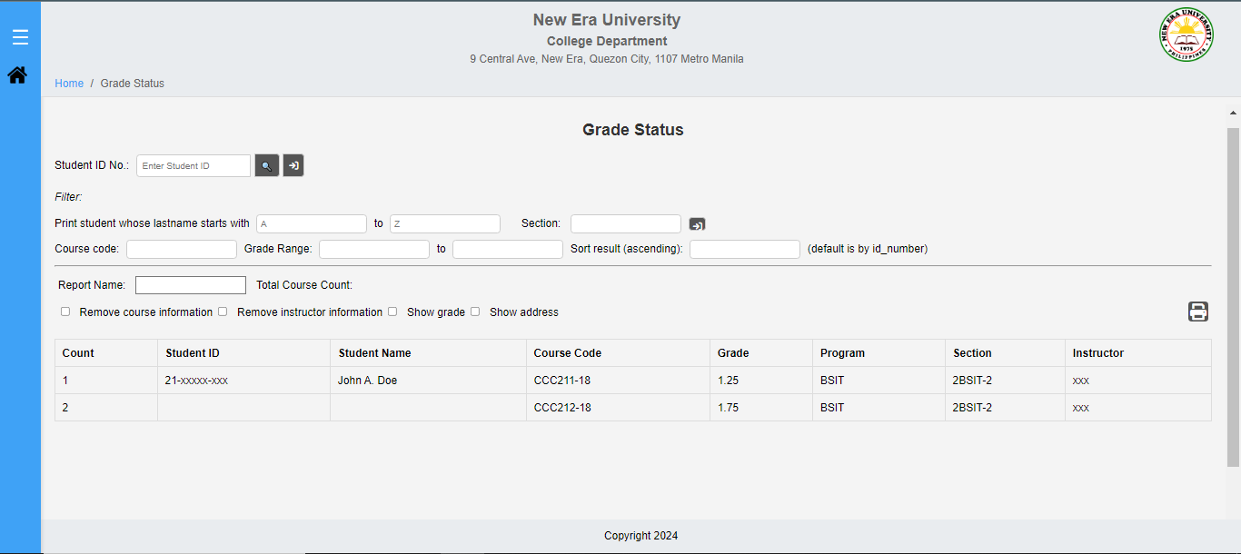

Module: Student Main Record  
Sub-Module: Student Schedule

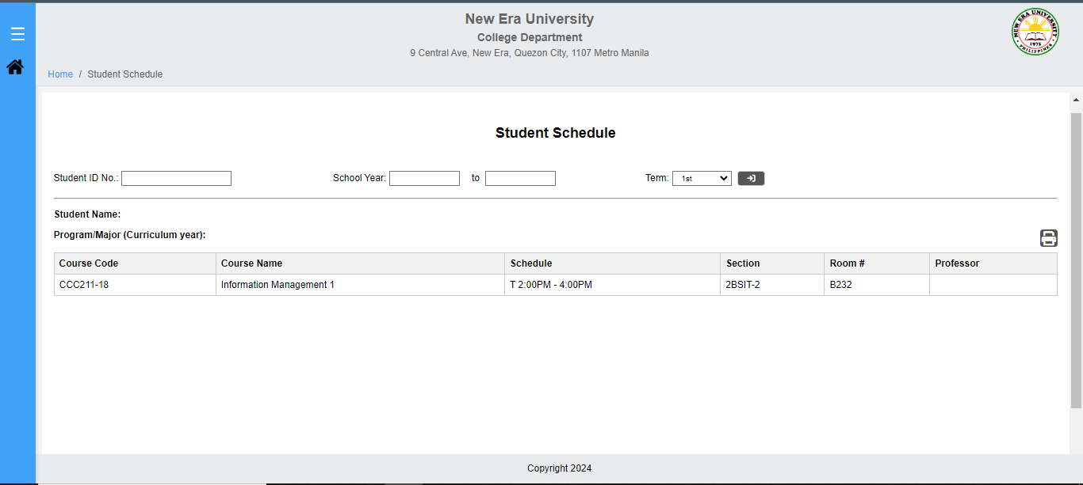

Module: Student Main Record  
Sub-Module: Residency Status

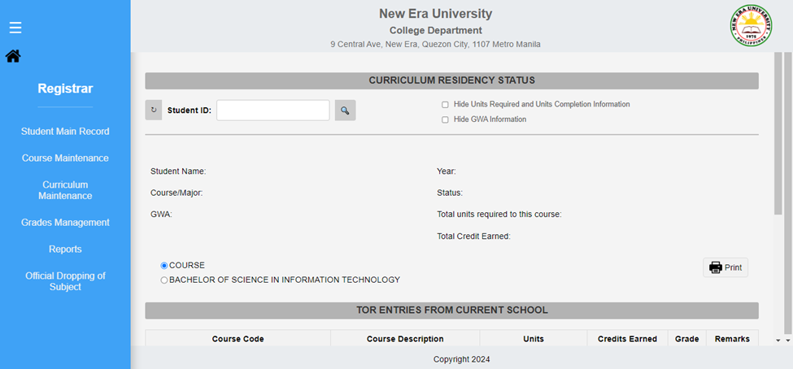

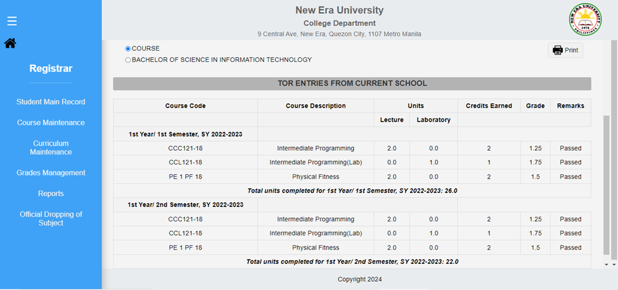

Module:Course Maintenance  
Sub-Module: Course Maintenance

View of Course Maintenance  
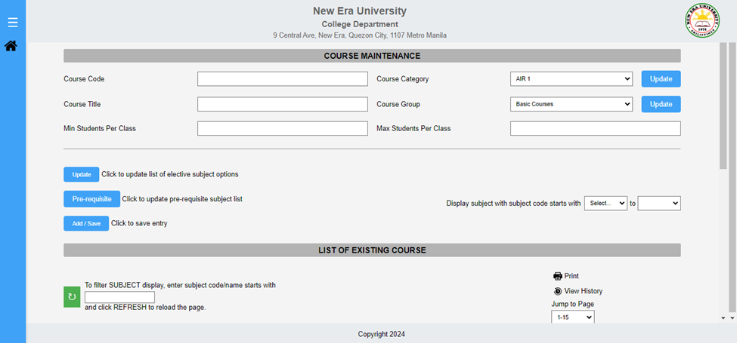

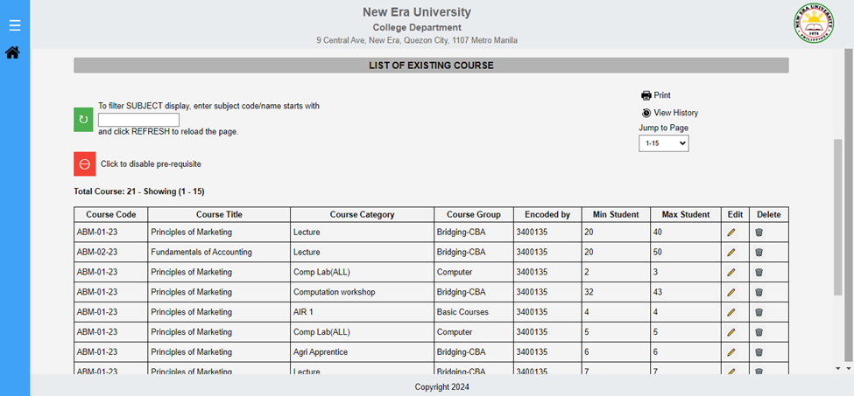

Course Category Dropdown Choices

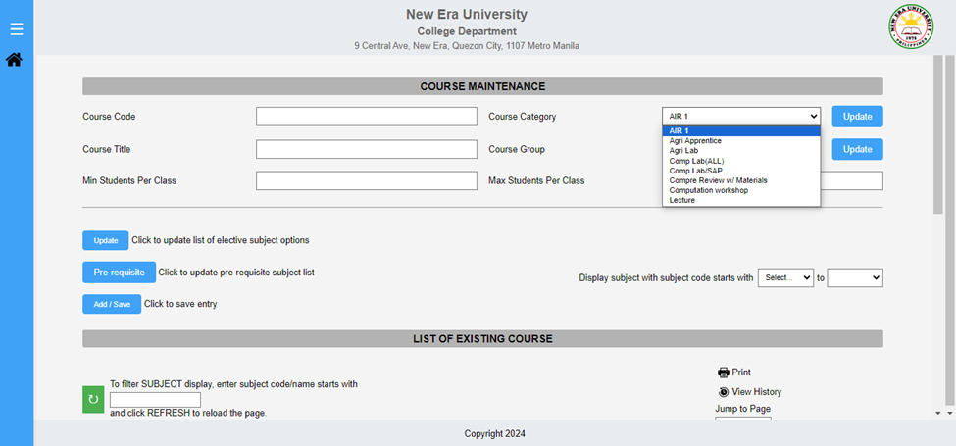

Course Category Update button

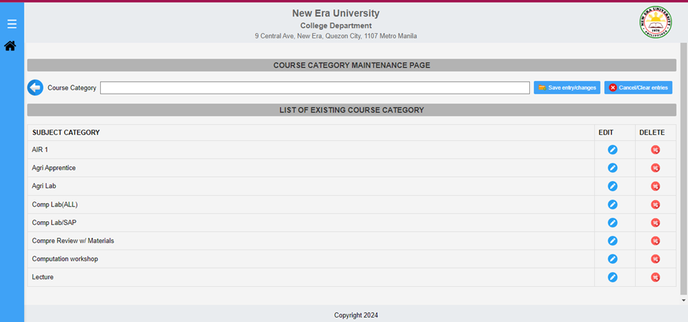

Course Group Dropdown choices

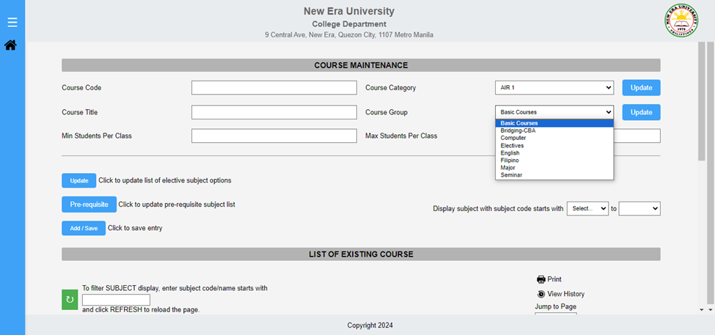

Course Group Update button

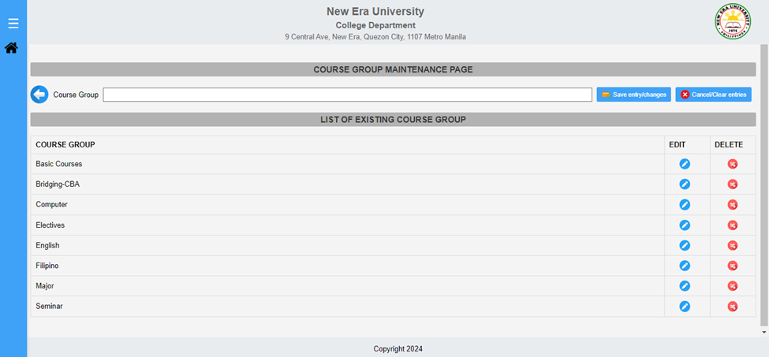

Prerequisite button

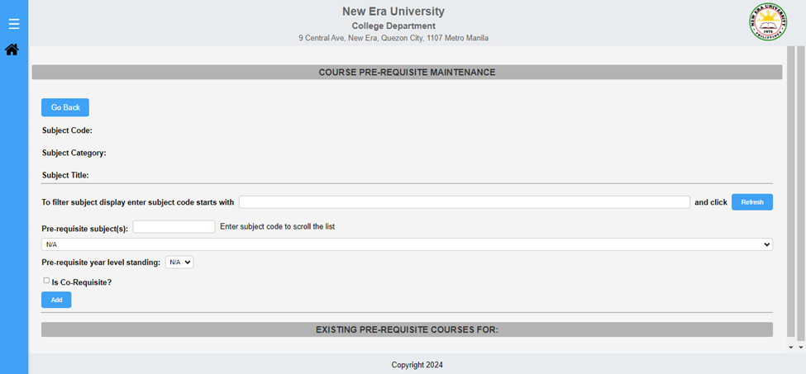

Display subject with subject code starts with

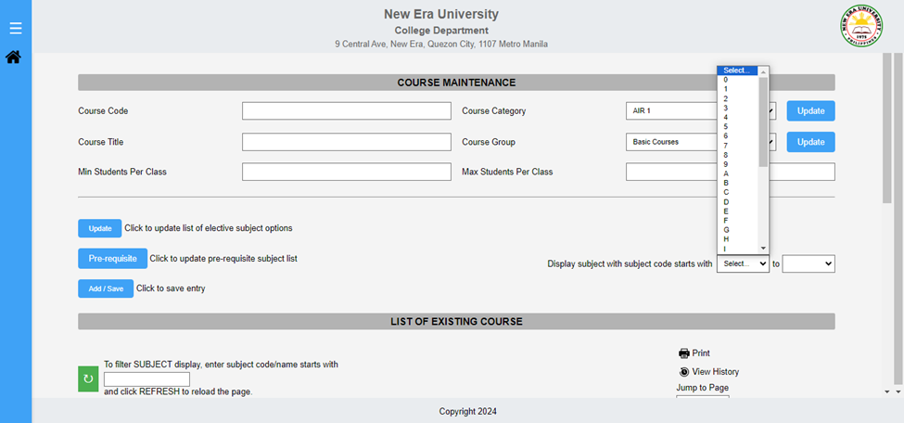

Filter Course Display -

Jump to Page -

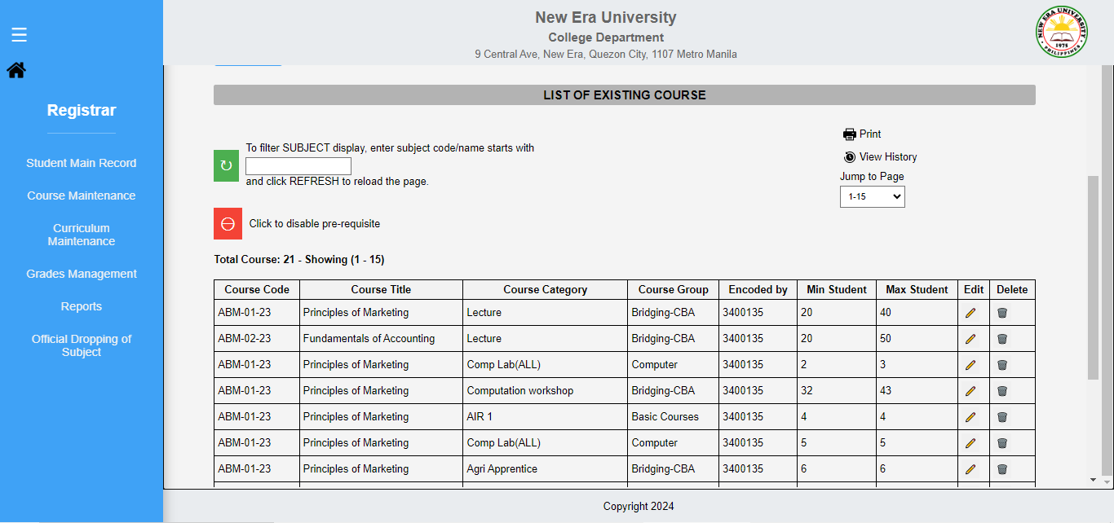

History button

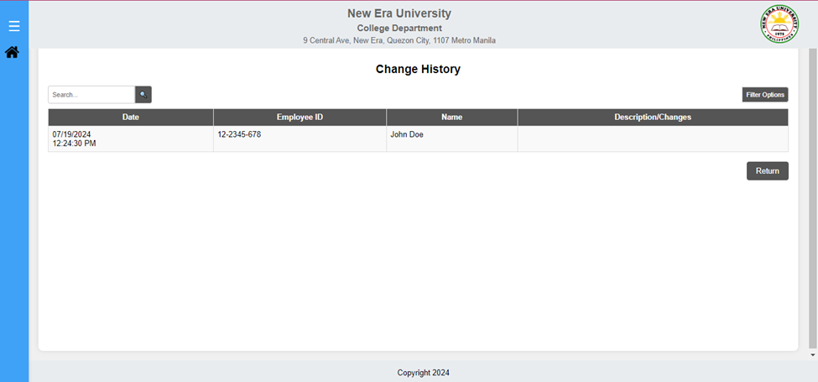

Print Button

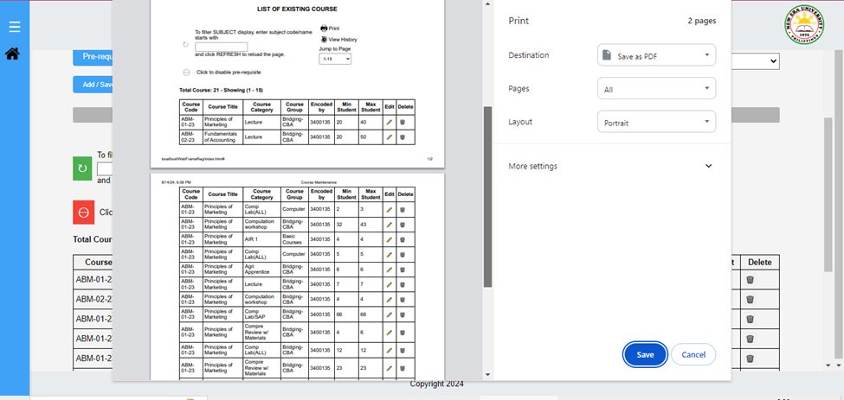

Module: Curriculum Maintenance  
Sub-Module: Course Program

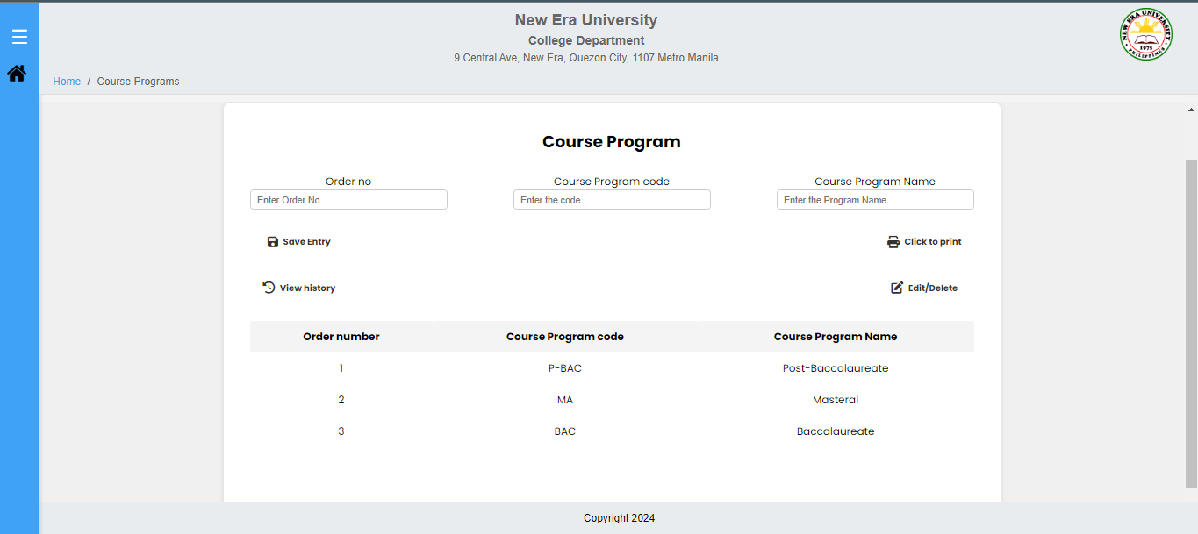

Module: Curriculum Maintenance  
Sub-Module: Colleges

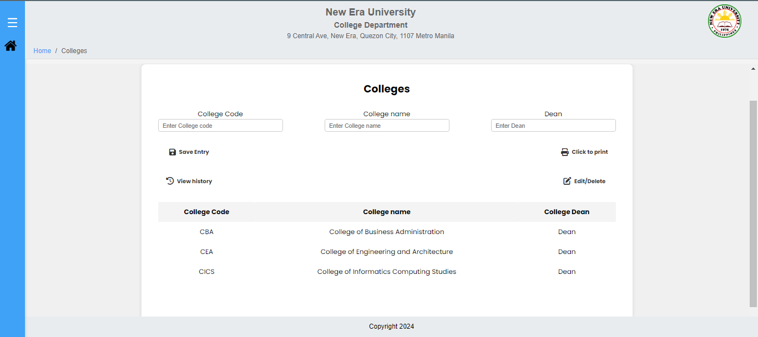

Module: Curriculum Maintenance  
Sub-Module: Departments

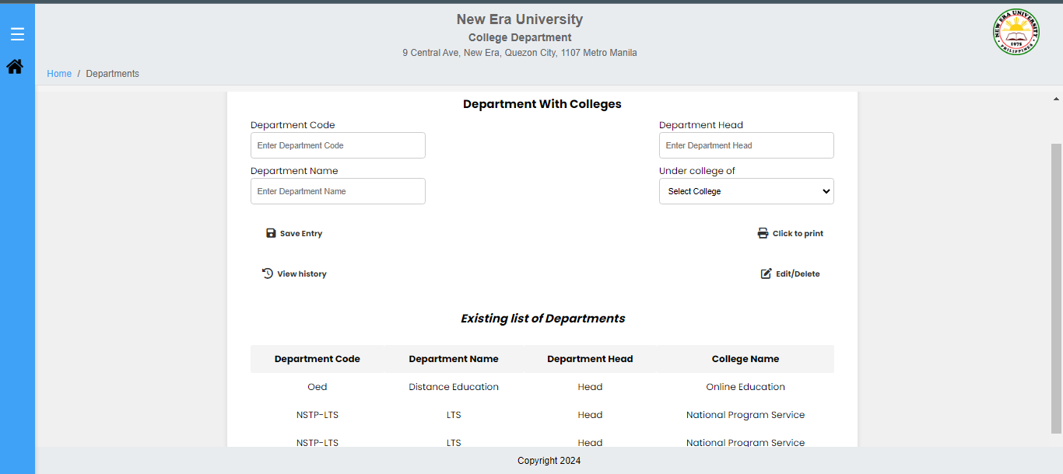

Module: Curriculum Maintenance  
Sub-Module: Department without College

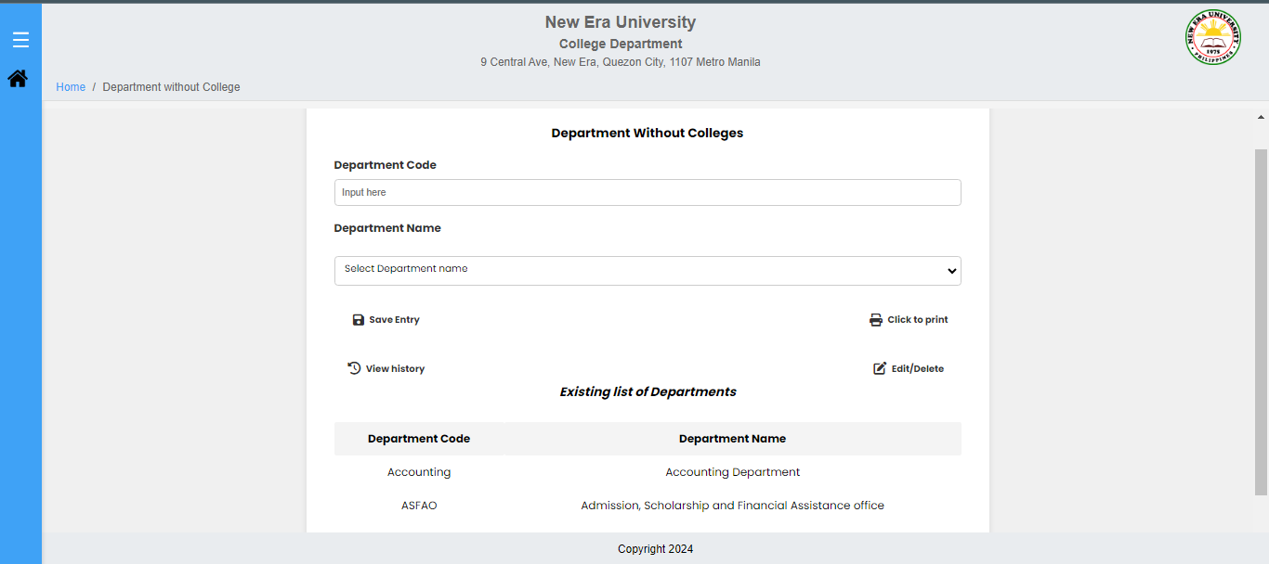

Module: Curriculum Maintenance  
Sub-Module: Courses

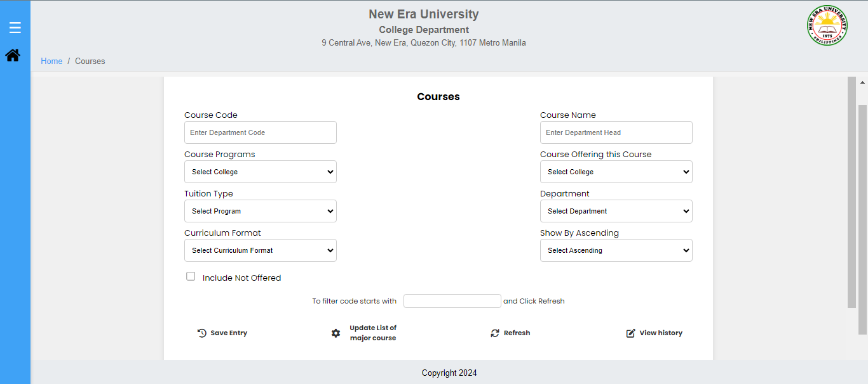

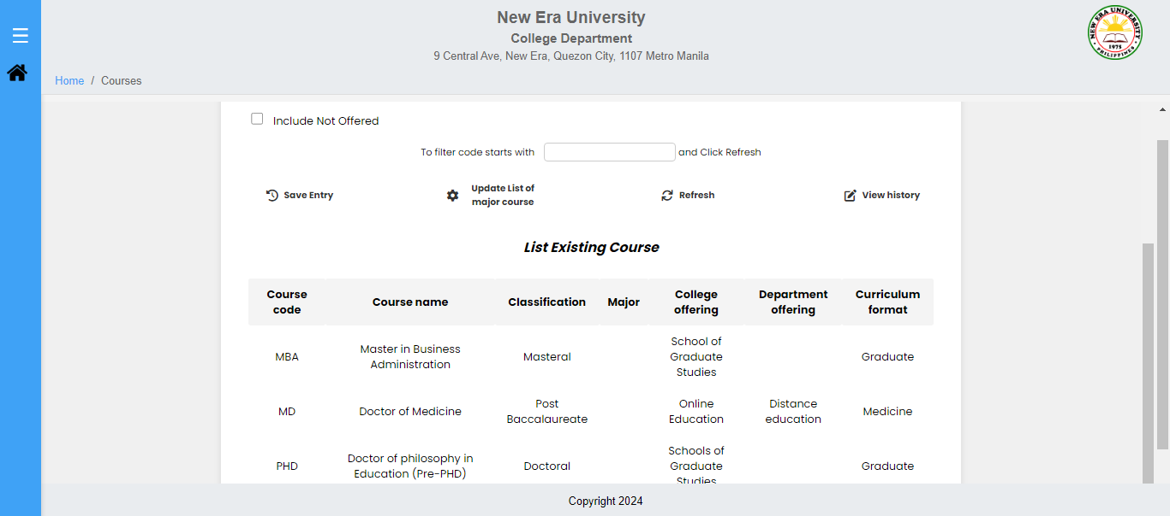

Module: Curriculum Maintenance  
Sub-Module: Equivalent Subject for Advising

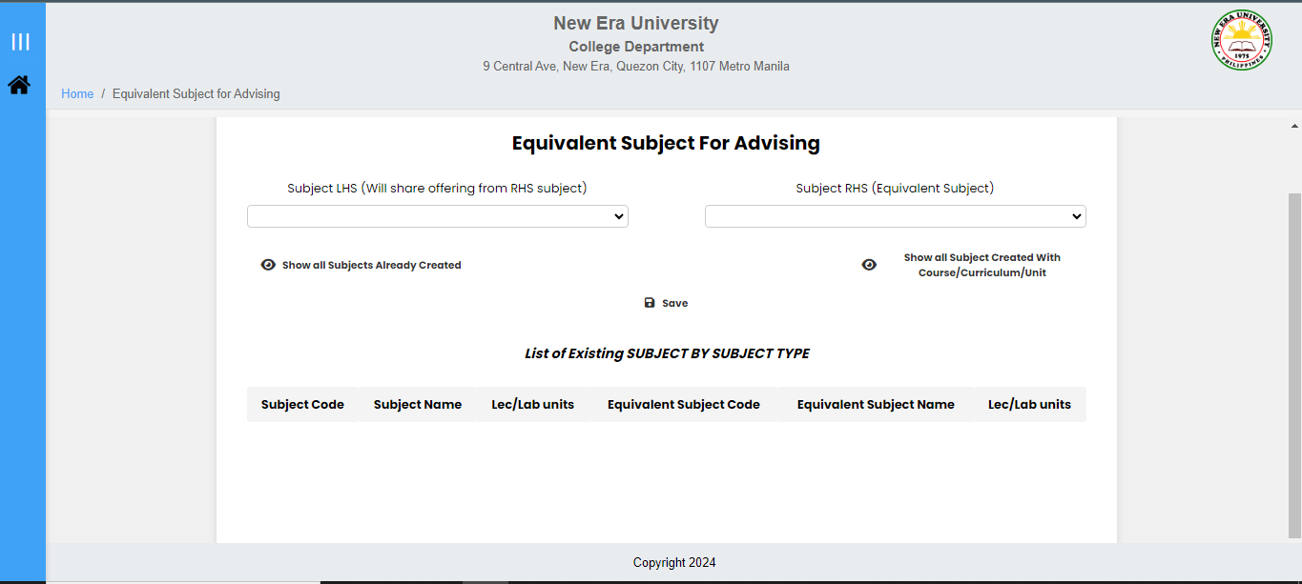

Module: Curriculum Maintenance  
Sub-Module: Subject Without Credit Unit

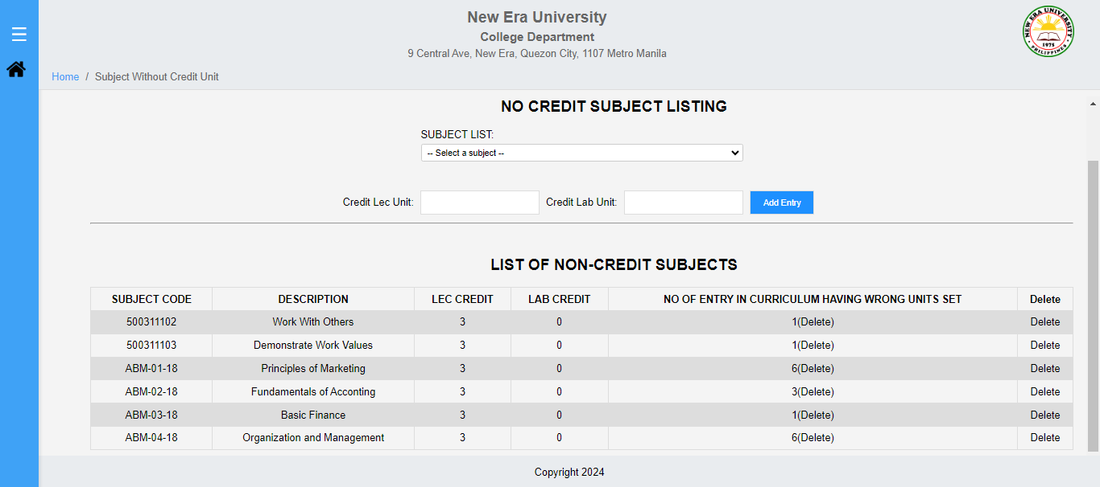

Module: Curriculum Maintenance  
Sub-Module: Course Curriculum

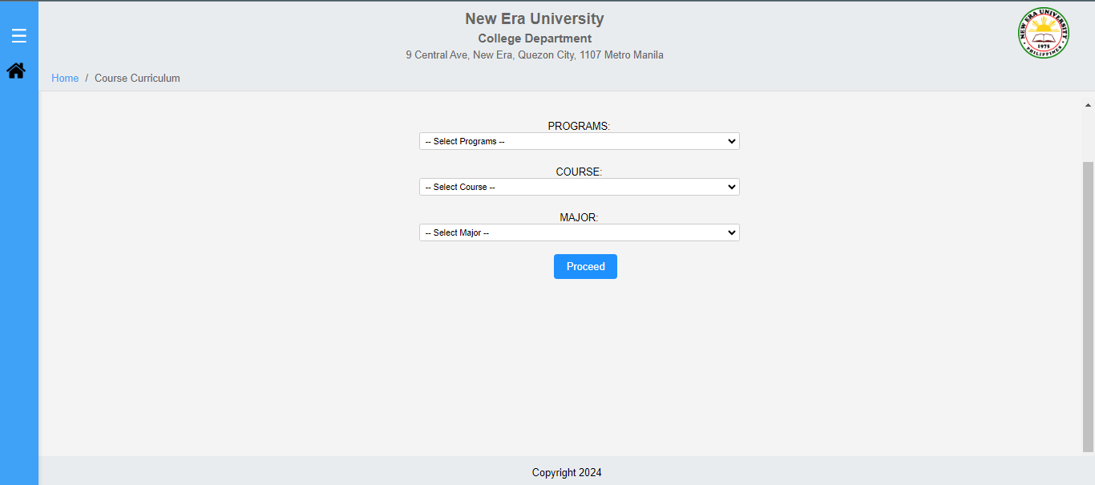

Module: Curriculum Maintenance  
Sub-Module: List of Course Offering Subject

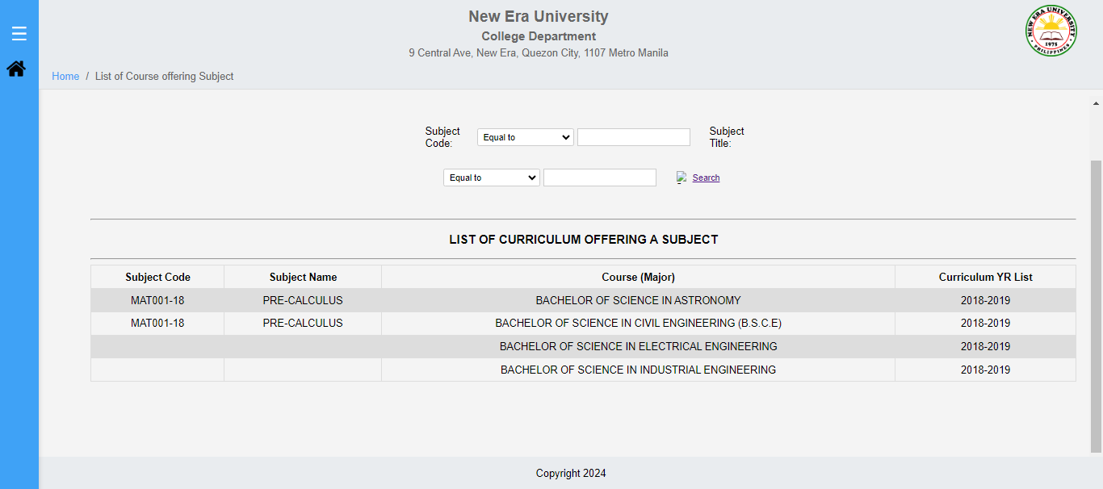

Module: Curriculum Maintenance  
Sub-Module: Copy/Delete Curriculum

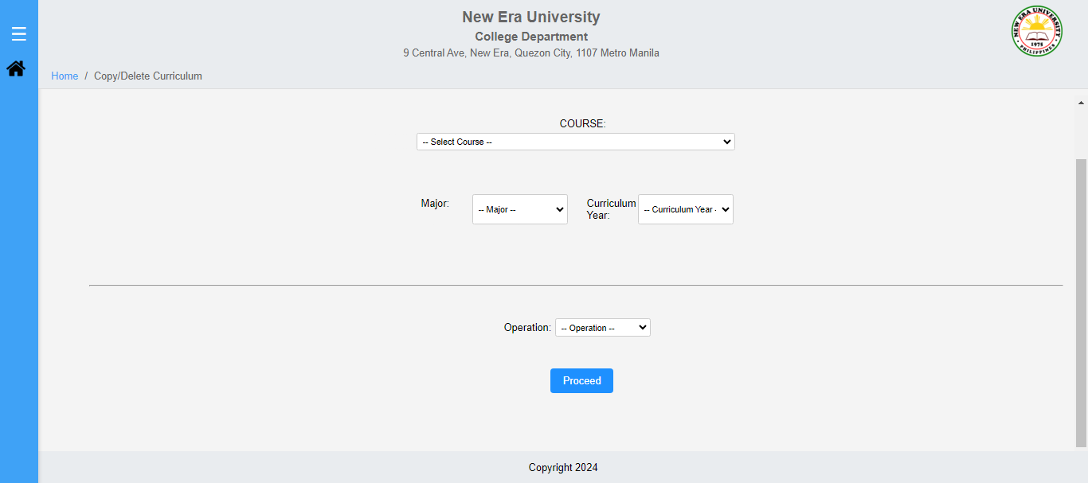

Module: Grade Management  
Sub-Module: Encoding of Grades - Status Report

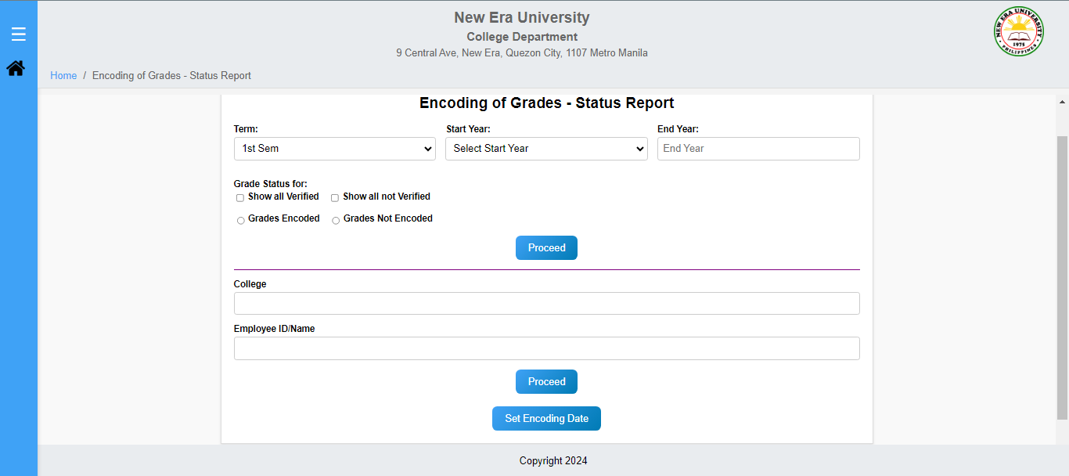

Module: Grade Management  
Sub-Module: Final Report of Grade

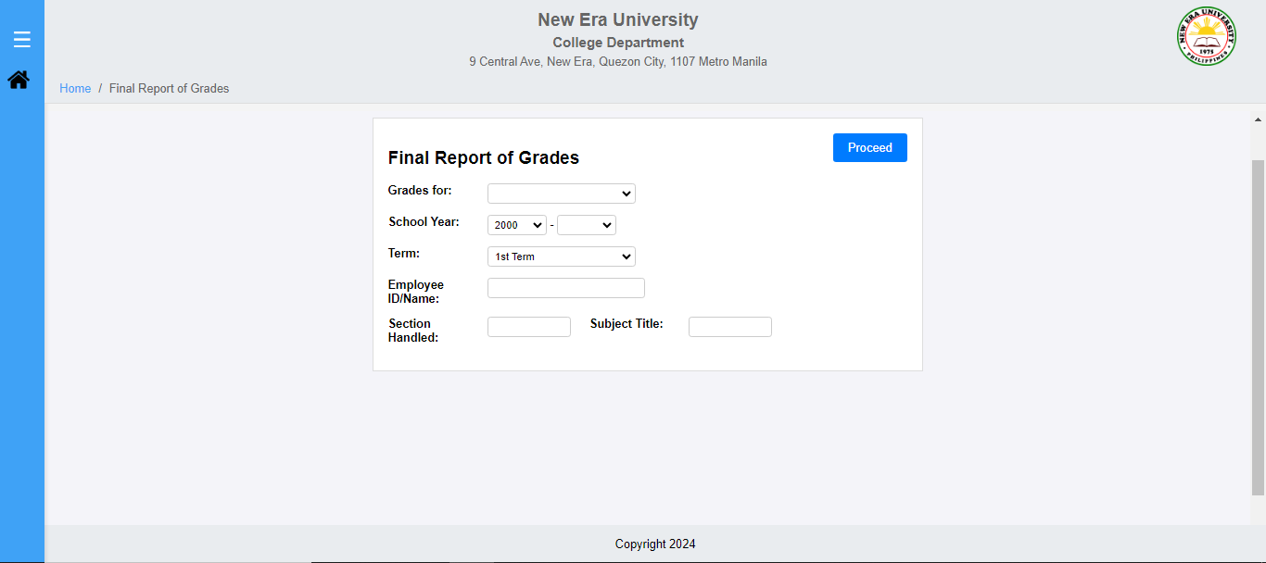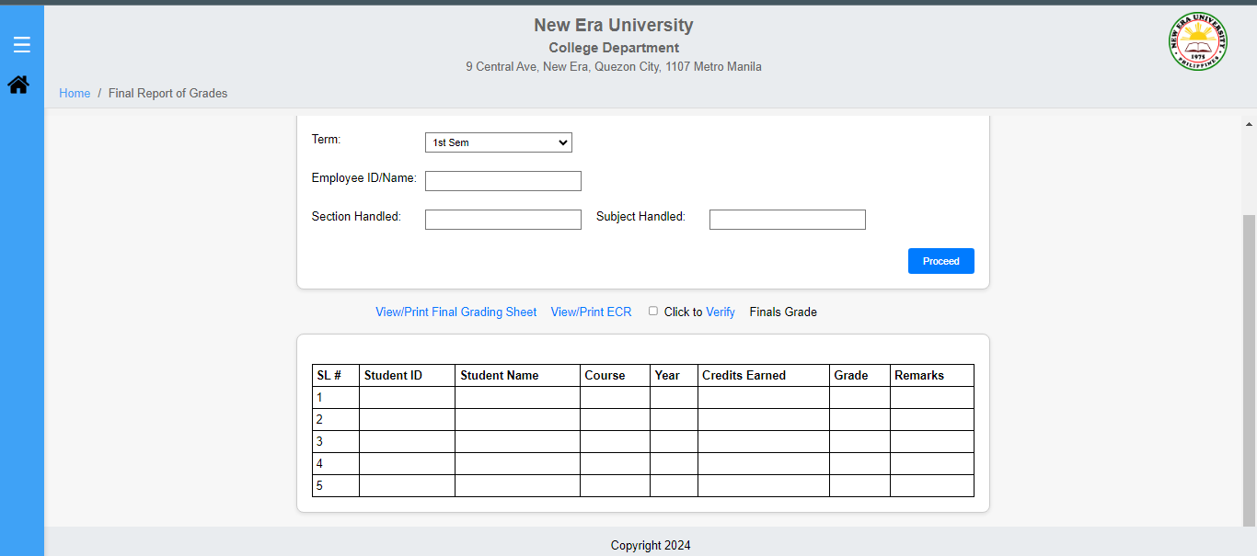Module: Grade Management  
Sub-Module: Rectification of Grades

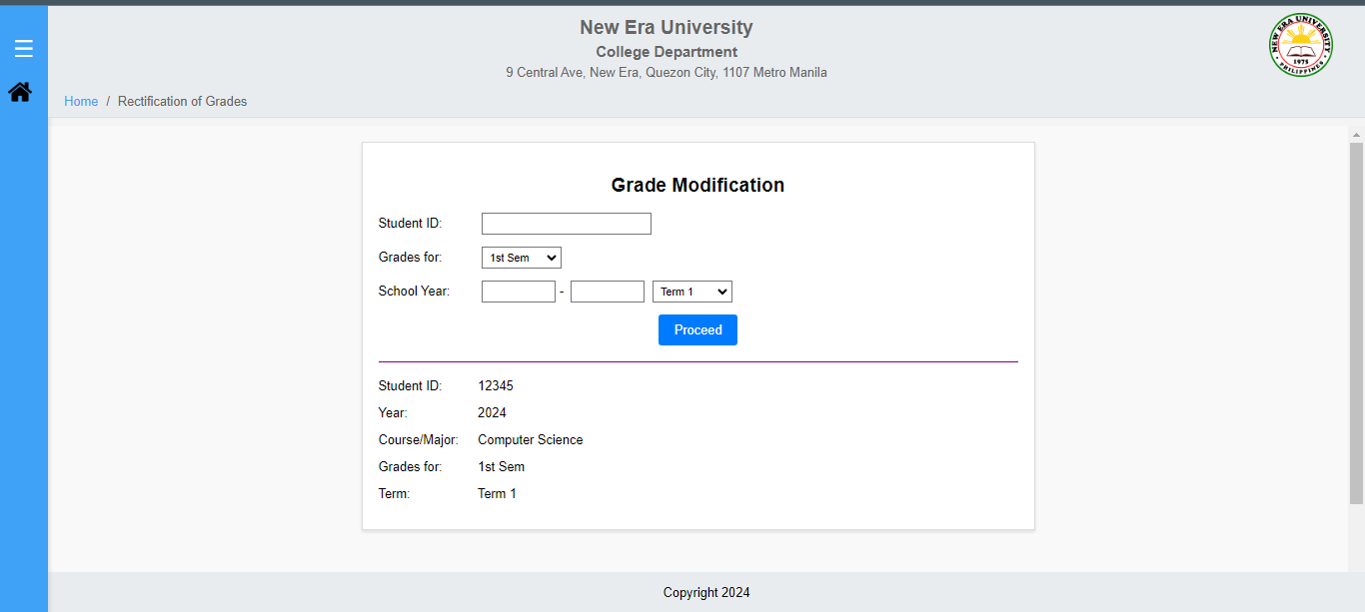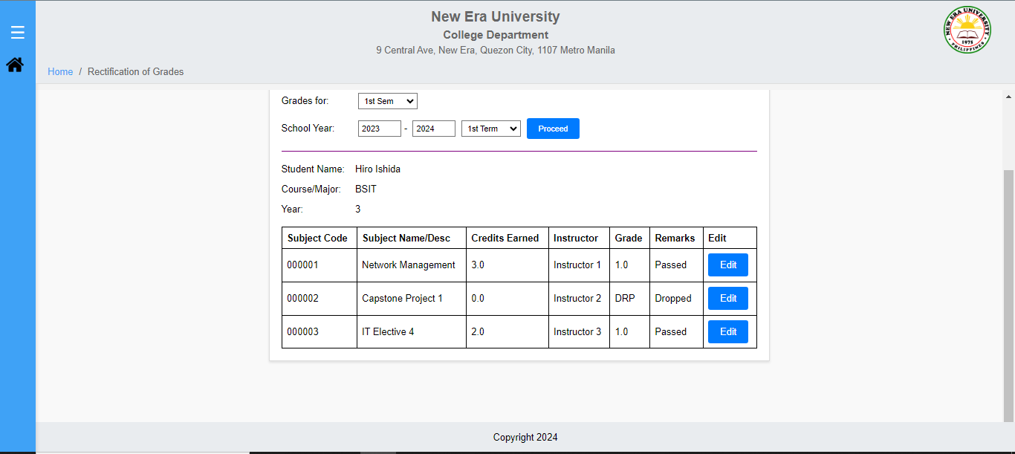

Rectification Edit Button  
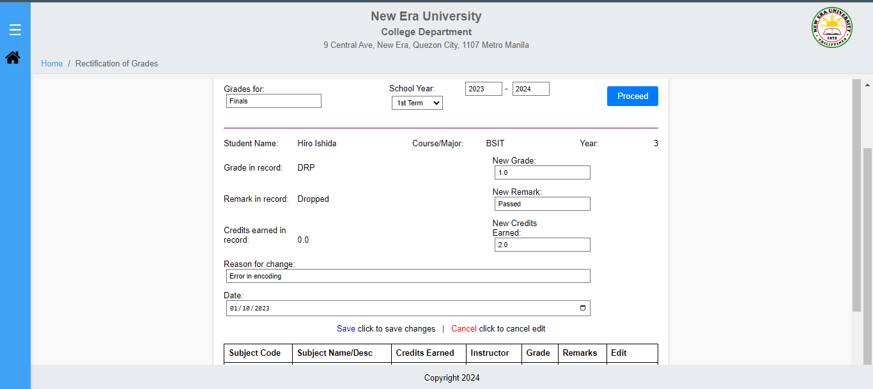

Module: Grade Management  
Sub-Module: Completion of Grades

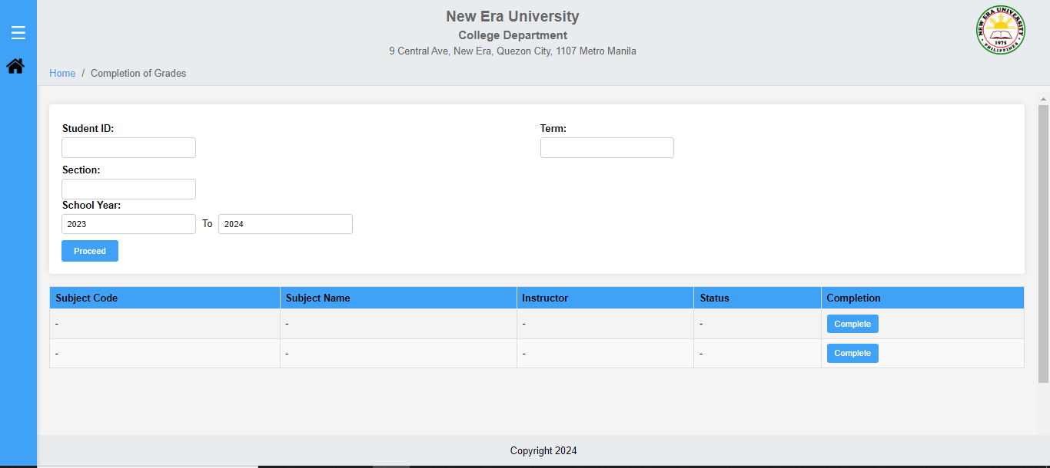

Module: Grade Management  
Sub-Module: Unlocking of Grades



Module: Reports  
Sub-Module: Official Transcript of Records

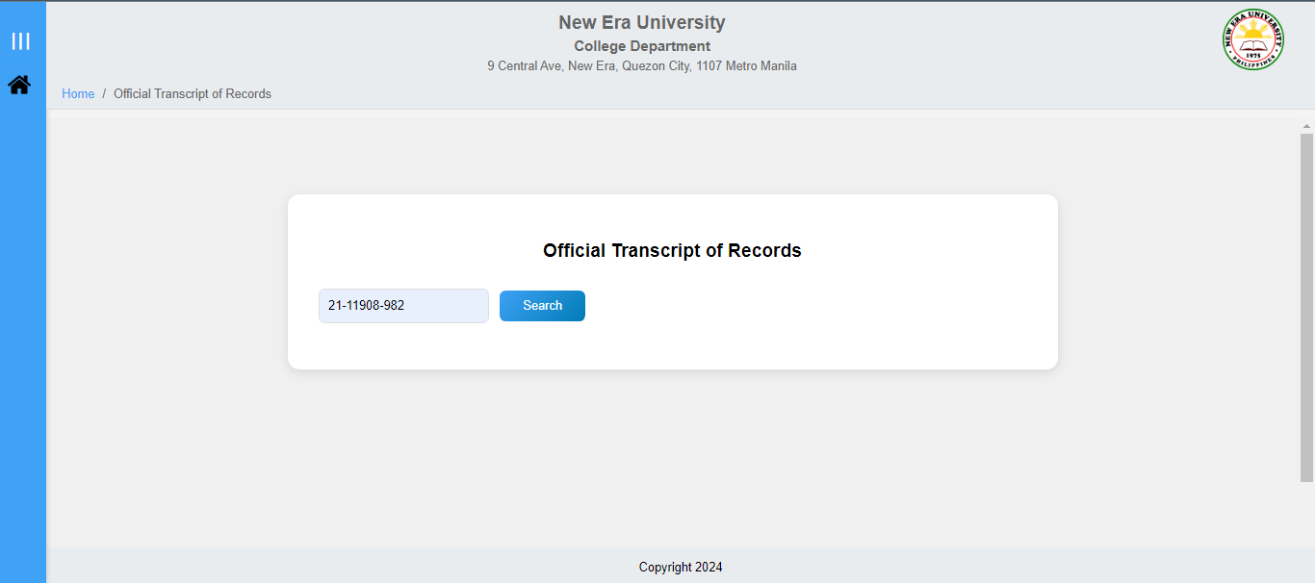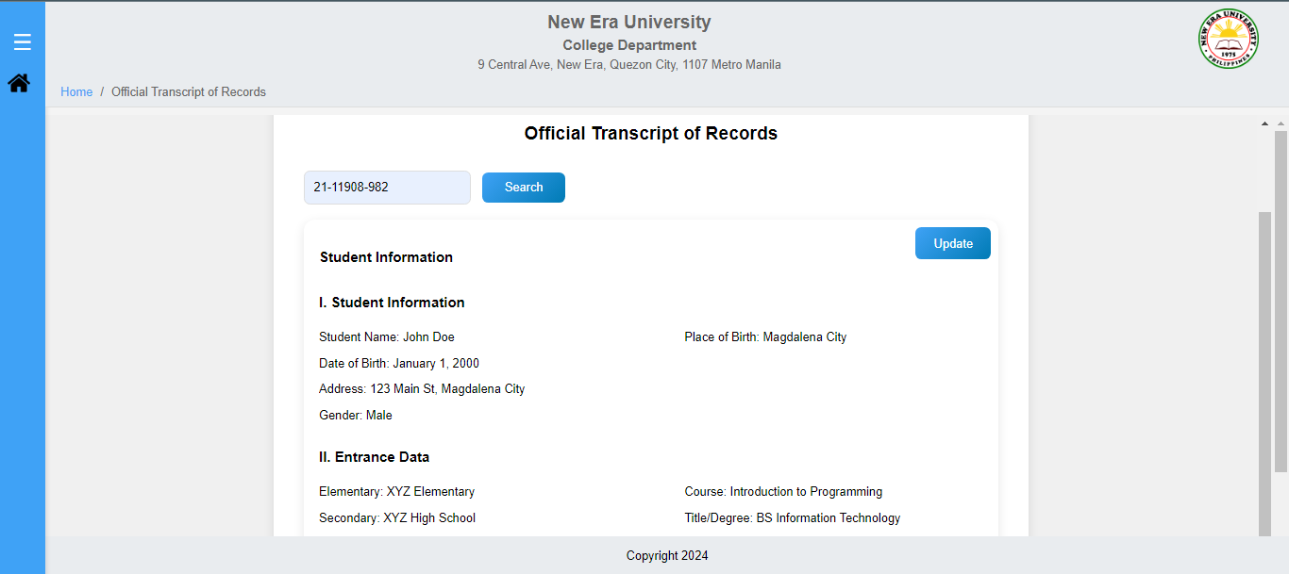

Update Button

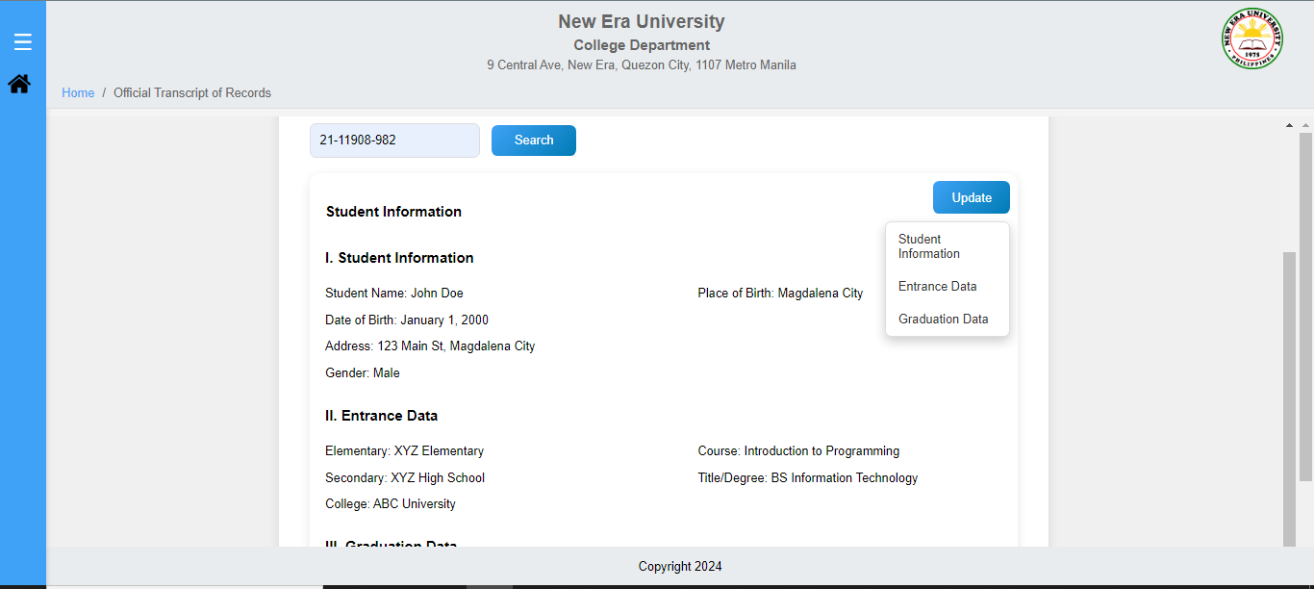

Module: Reports  
Sub-Module: Official Transcript of Records of Candidate for Graduation

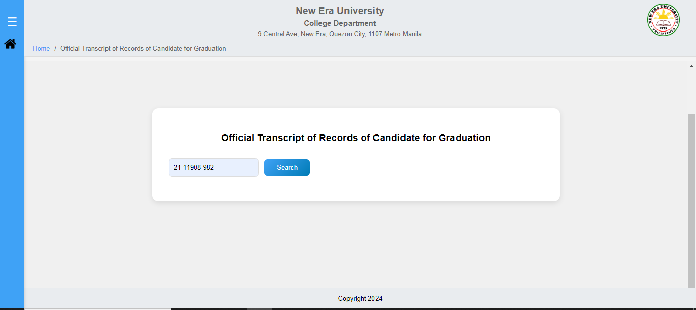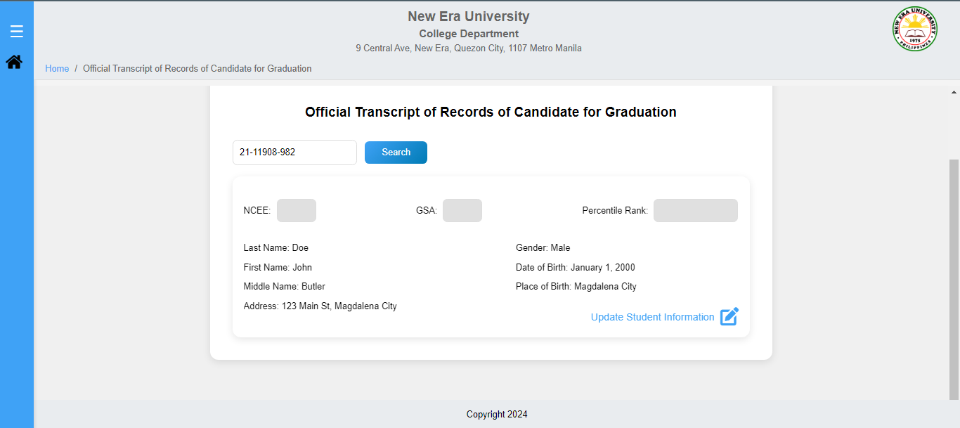

Update Student Information

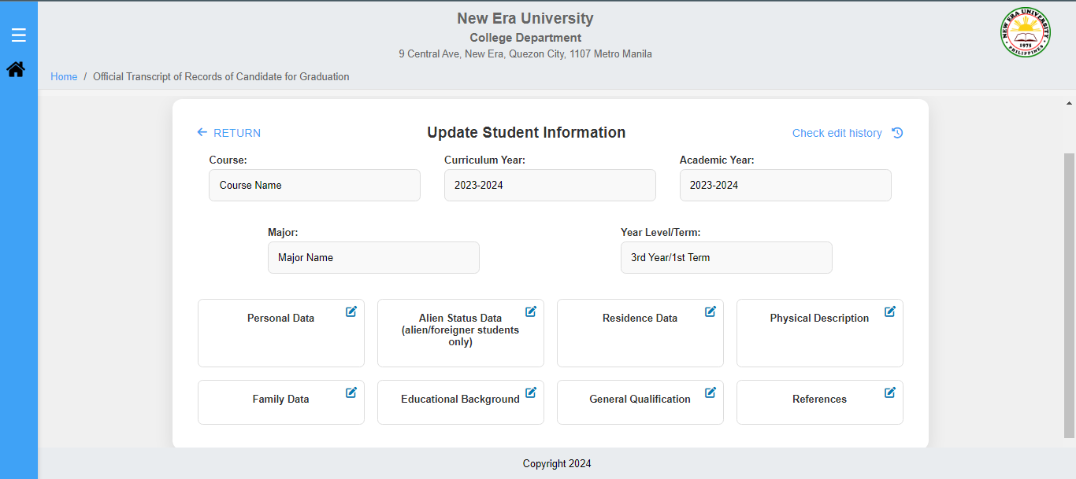

Module: Reports  
Sub-Module: Candidate for Graduation

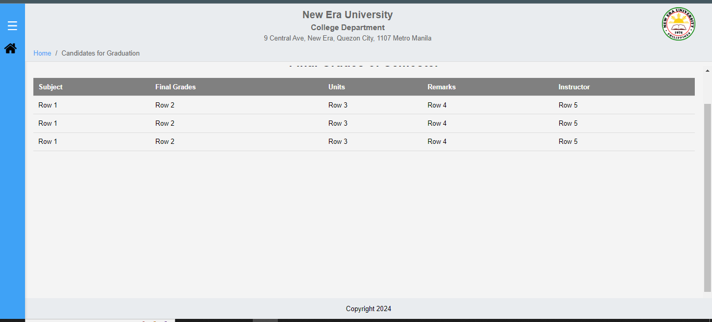

Module: Reports  
Sub-Module: Certification of Grades

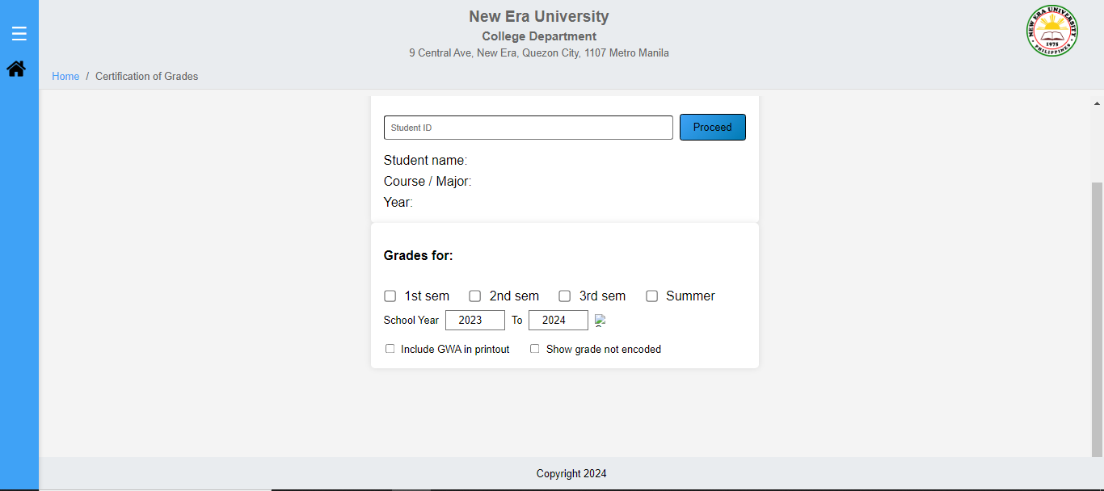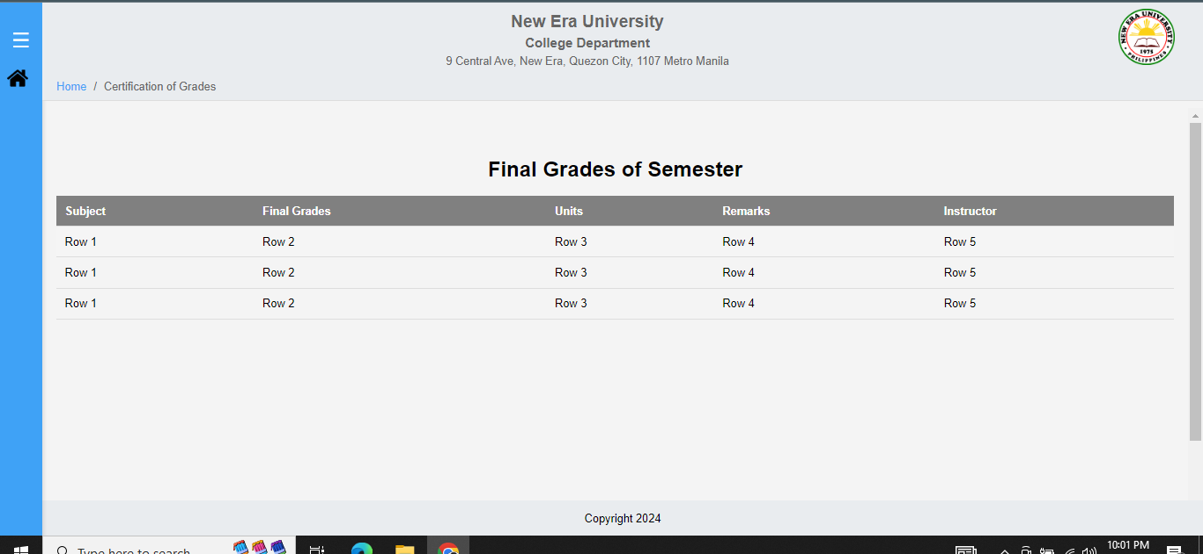

Module: Reports  
Sub-Module: Evaluation of Grades

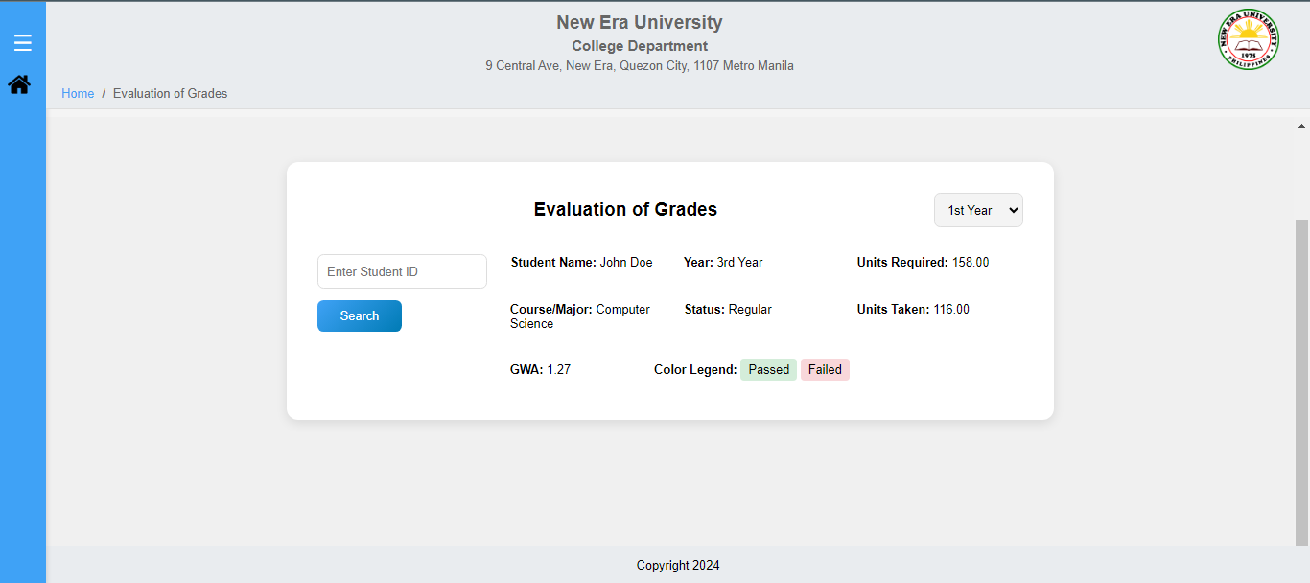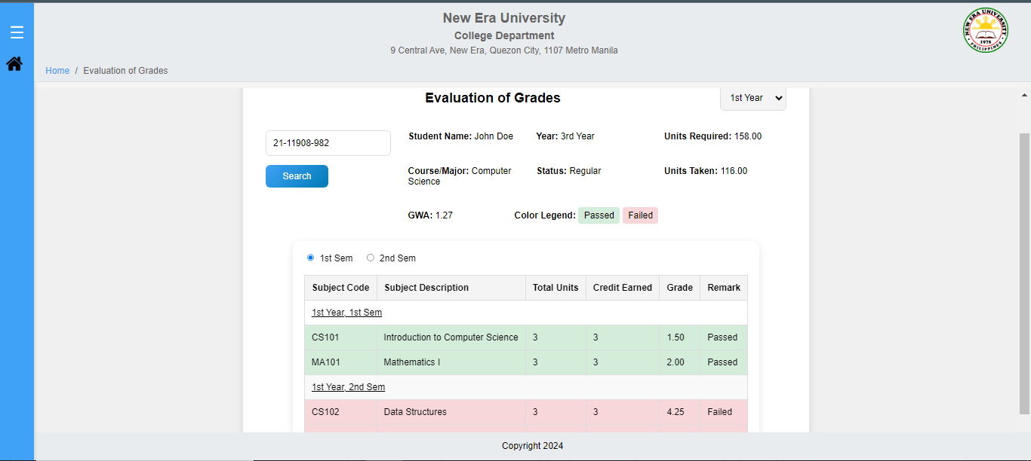

Module: Official Dropping of Subject

